WRITTEN INFORM

Thinkpad Lenovo L450

INTEGRANTE: Alejandro Calderón

PROFESOR: Jorge Cristian Flores Feliú

FECHA ENTREGA: 15-06-2021

Index

1 Introduction 3

2 Development 4

2.1 Data and characteristics 4

2.2 Advantages 4

2.3 Disadvantages 4

2.4 Comparison 4

3 Conclusion 6

# Introduction

In this written inform will refer to my main work tool, which is my Lenovo L450 notebook from the Lenovo Thinkpad series, without this laptop I could not perform my daily work, now with the COVID 19 has become essential in my daily life, therefore my choice.

# Development

## Data and characteristics

Thinkpad Lenovo L450 is part of a series of business laptops, along with the E and T series, this notebook was made in China in Lenovo factories, this model has a 14-inch screen, which poses a thinner and lighter model for everyday transport, Specifically my notebook has Intel core i5-5300 vpro processor, factory this notebook brought 8 gb of Ram, but I have added 8 extras for speed, as I have also changed its 256 GB SSD disk by one of 512 Gb for more space, has an Intel HD 5500 graphics card which is integrated into the processor.

## Advantages

The advantages are as follows:

1. Easy Transportation, for daily work
2. High resistance, endurance components
3. Good performance, on relation quality and price

## Disadvantages

The disadvantages are as follows:

1. Poor video camera quality
2. Poor battery life
3. No fingerprint reader, and the other telemetry validations

## Comparison

The comparisons are as follows:

1. This Notebook isn’t fast as a gamer PC.

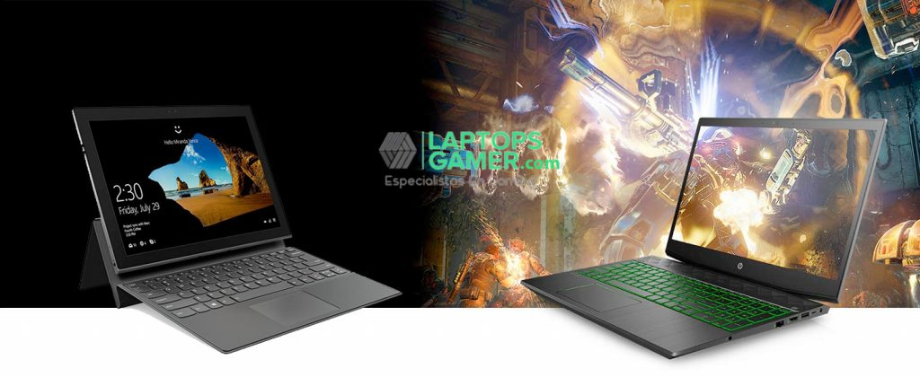

1. This Notebook is easier than transporting as a Desktop PC.

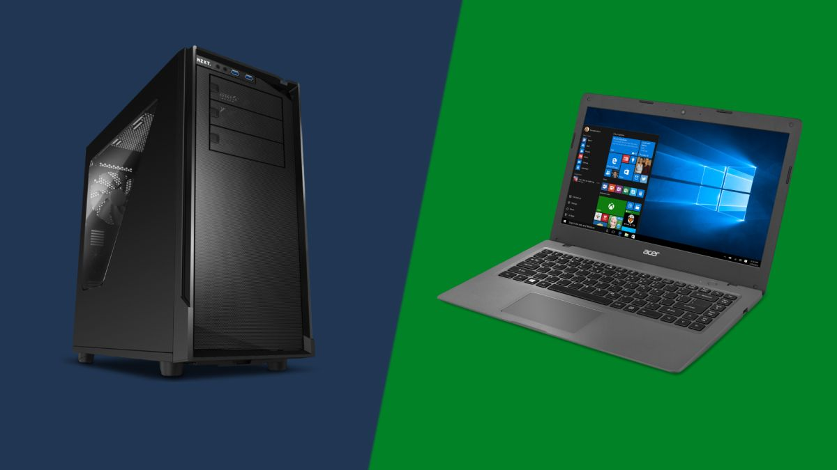

1. This device is a fast as I expected.

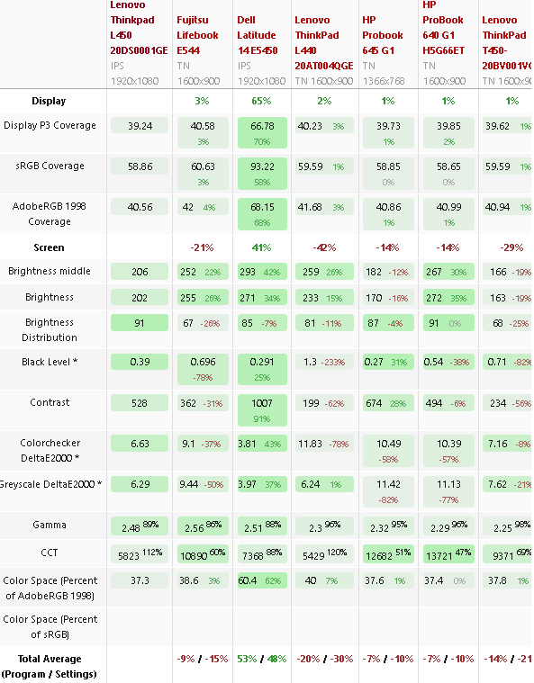

1. My notebook battery doesn’t last as long as the Dell’s.

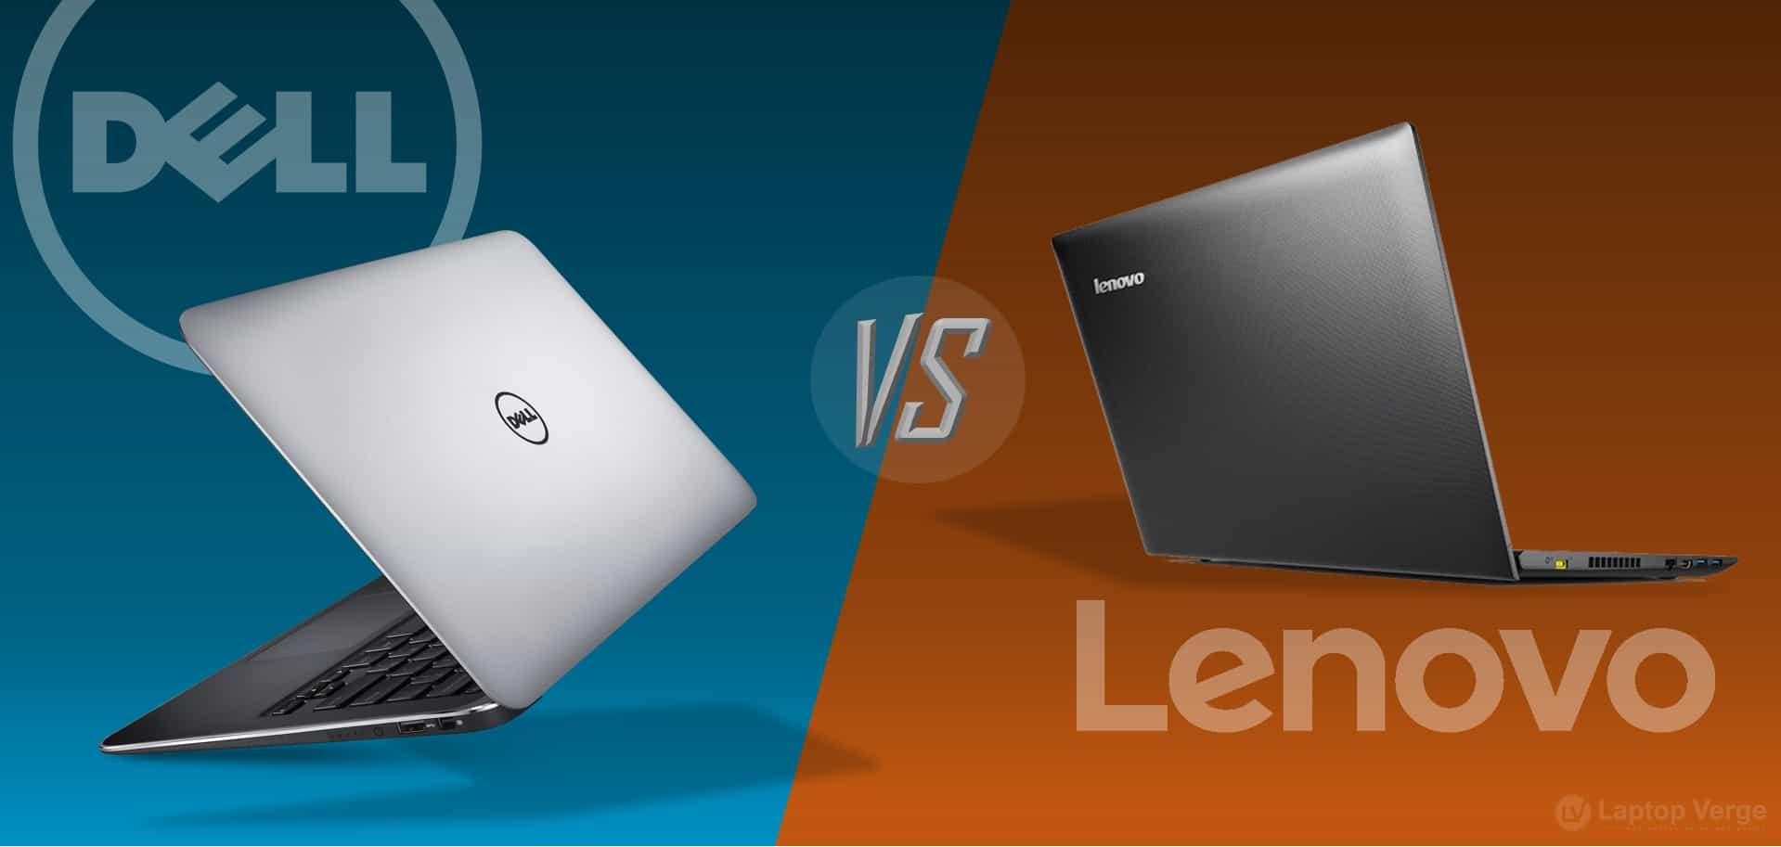

1. 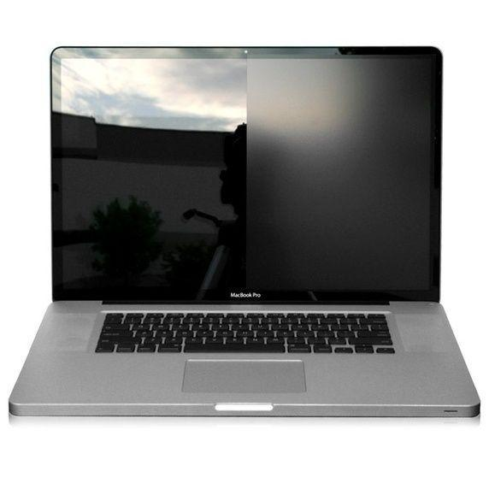The screen of my notebook reflects the brightness of the sun does not like as the newest PC’s screen

# Conclusion

In conclusion, for the tasks that I perform daily in my work this notebook has a great performance, since I do not use large hardware capacity, but for the way I work, I need a good data processing and the possibility of connecting to the internet, while supporting the management modules of the Microsoft suite, fulfilling this and wanting to conclude this is an excellent machine for me and I would not change it, at least, in a while.